MEETING MINUTES

Topic: Final Design of Chamber

Tuesday, March 28, 2017

2:30 pm – 3:20pm

Minutes recorded by Sharna Beahm

Attendees: Sharna Beahm, Riley Ducey, Isaiah Cons

Ion gun arrived
- Unpackaged and measured!

- 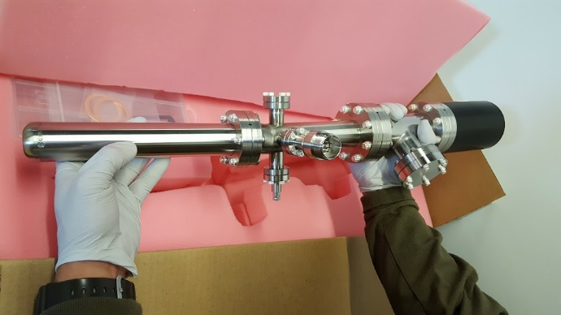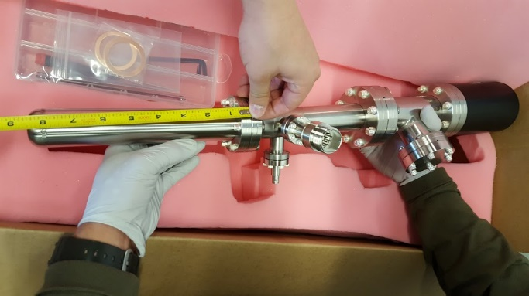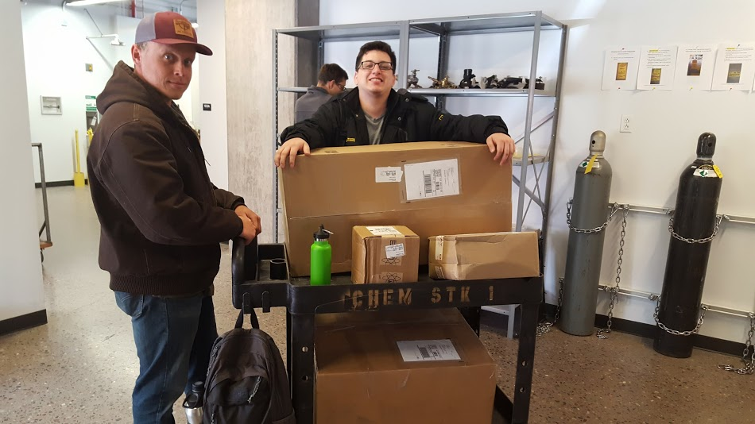
We were very excited!
- Stands
  - 3D print is being finalized by Sharna for the chamber.
  - Modifications still needed before print
  - Should be done by 3-29-17
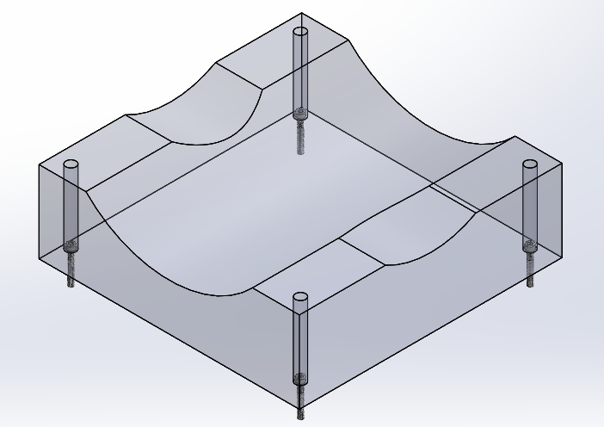
Figure: chamber support

  - Once chamber is complete TOF and ion gun stands will be designed next

